Create table with engine InnoDB (this engine implements referential integrity). Example:

create table r1 (

f1 varchar(5) not null,

f2 varchar(40) not null,

constraint r1_pk primary key (code)

)  ENGINE=InnoDB;

1.- Create a database with name “P01” using the shell and DDL.



2.- Inside the database P01 create the table MOVIES with the next fields and constraints:

|  |  |  |  |
| --- | --- | --- | --- |
| **Field name** | **Domain** | **Required?** | **Default value** |
| **code** | varchar(5) | Yes |  |
| **title** | varchar(40) | Yes |  |
| **date_added** | date | No | 07/01/19 |
| **price** | float | Yes |  |

The column ‘code’ is the primary key of the table.

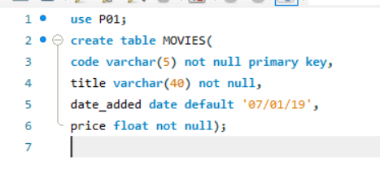

3.- Insert the flowing data inside the MOVIES table:

|  |  |  |  |
| --- | --- | --- | --- |
| **MOVIES** | | | |
| **code** | **tittle** | **date_added** | **price** |
| GODF1 | The Godfather | NULL | 10.55 |
| GODF2 | The Godfather: Part II | 07/01/18 | 11.20 |
| GODF3 | The Godfather: Part III | 05/02/18 | 9.25 |
| NEMO1 | Finding Nemo | 06/02/18 | 14.95 |

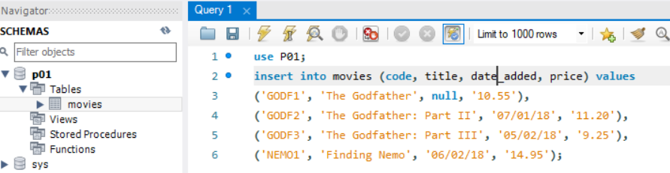

4.- Inside the database P01 create the table CUSTOMERS with the next fields and constraints:

|  |  |  |  |
| --- | --- | --- | --- |
| **Field name** | **Domain** | **Required?** | **Default value** |
| **NIF** | varchar(9) | Yes |  |
| **name** | varchar(40) | Yes |  |
| **surname** | varchar(40) | Yes |  |
| **postal_code** | varchar(5) | No | ‘07006’ |
| **date_of_birth** | date | No |  |

The column ‘NIF’ is the primary key of the table.

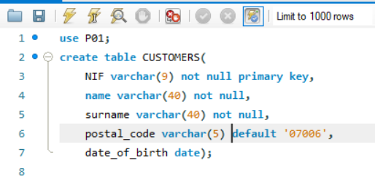

5.- Insert the flowing data inside the CUSTOMERS table:

|  |  |  |  |  |
| --- | --- | --- | --- | --- |
| **CUSTOMERS** | | | | |
| **NIF** | **name** | **surname** | **postal_code** | **date_of_birth** |
| 12345678W | Sergi | Smith | 07001 | 14/1/1977 |
| 23456789Q | John | Connor | 28080 | 22/2/1954 |

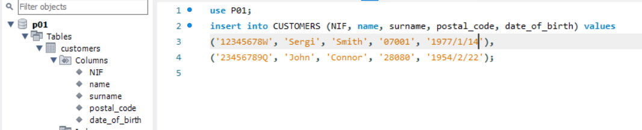

6.- Inside the database P01 create the table ORDERS with the next fields and constraints:

|  |  |  |  |
| --- | --- | --- | --- |
| **Field name** | **Domain** | **Required?** | **Default value** |
| **code** | varchar(5) | Yes |  |
| **NIF** | varchar(9) | Yes |  |
| **date** | date | Yes |  |
| **qty** | int | Yes | 1 |

The columns ‘code’, ‘NIF and ‘date’ are the primary key of the table. Moreover, code and NIF are foreign keys.

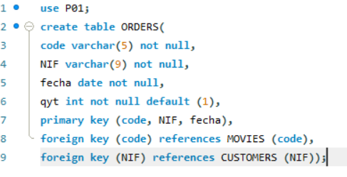

7.- If you insert the flowing data inside the ORDERS table you won’t be able to do it. Explain why:

|  |  |  |  |
| --- | --- | --- | --- |
| **ORDERS** | | | |
| **code** | **NIF** | **date** | **qty** |
| SCARY | 12345678W | 14/11/2018 | 1 |
| NEMO1 | 12345678W | 15/11/2018 | 2 |

No, no me deja realizarlo porque el ‘code’ es una foránea y la he de coger del ‘code’ de la tabla MOVIES, y como en la tabla MOVIES no hay ningún code con ‘SCARY’ pues no me deja insertarlo, pero si intento insertar la de ‘NEMO1’, entonces sí me deja porque en la tabla MOVIES sí hay un code ‘NEMO1’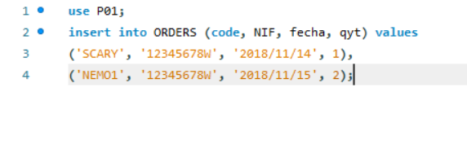

8.- Insert into CUSTOMERS:

|  |  |  |  |  |
| --- | --- | --- | --- | --- |
| **CUSTOMERS** | | | | |
| **NIF** | **name** | **surname** | **postal_code** | **date_of_birth** |
| 77777777C | Francisco | Gomis | 07006 | 13/12/1967 |
| 88888888F | Antonio | Mulet | 07002 | 25/5/1984 |

After that, write a statement to delete all the customers who were born before 1/2/1970.

Finally, change the name 'Sergi' to 'Sergio' to the customer with NIF '12345678W'.

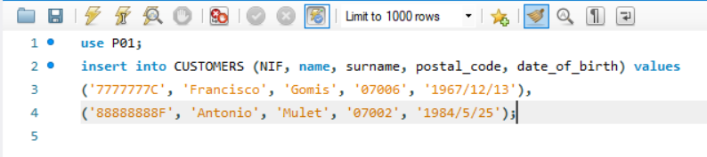

9.- Create the following tables inside a database “INSURANCE”:

1. Create a table called PEOPLE with the fields (nif, name, surname).
2. Create a table called VEHICLES with the fields (plate_number, model). The field ‘model’ is a foreign key referencing MODEL table.
3. Create a table called BRANDS with the field (code, name).
4. Create a table called MODELS with the field (code, name, brand). The field ‘brand’ is a foreign key referencing BRANDS.
5. Create a table called PEOPLE_VEHICLES with the fields (nif, plate_number). The fields ‘nif’ and ‘plate_number’ are foreign keys referencing PEOPLE and VEHICLES tables, respectively.

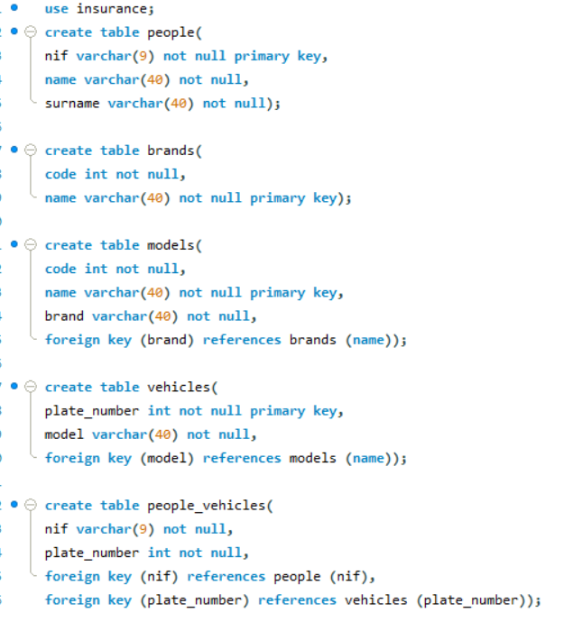

10.-

A. Explain why it doesn’t work (don’t do anything before):

* INSERT INTO PEOPLE_VEHICLES (plate_number, nif) VALUES ('1111BBB', '12345678A');

Porque plate_number y nif de people_vehicles son foráneas de people y models, por tanto primero deberían estar en people y models, no se puede insertar directamente en people_vehicles.

B. Now execute:

* INSERT INTO PEOPLE (nif, name, surname) VALUES ('12345678A', 'Sergi', 'González');
* INSERT INTO BRANDS (code, name) VALUES ('VOLKS', 'Volkswagen');
* INSERT INTO MODELS (code, name, brand) VALUES ('GOLF9', 'Golf Limited Edition 2018', 'VOLKS');
* INSERT INTO VEHICLES (plate_number, model) VALUES ('1111BBB', 'GOLF9');

C. Does it work now the sentences of paragraph A?

Siii, porque han sido introducidos en las tablas people y models.

D. Explain why it doesn’t work (don’t do anything before):

* INSERT INTO MODELS (code, name, brand) VALUES ('LEON5', 'Leon Limited Edition 2018', 'SEAT');

Daría error porque ‘seat’ no existe en la tabla brands y como Brand de tabla models es foránea de la tabla Brands, si no existe primero en brands no puede existir en models.

E. Check if the next doesn’t work (don’t do anything before):

* INSERT INTO BRANDS (code, name) VALUES ('PORSCHE', 'Porsche');

Did it happen anything strange?

Funciona

F. Delete the brand with code 'VOLKS' and see what does it happen.

No me deja borrarlo porque la tabla models depende de brands.

11.- Add a column ‘description’ to the table ‘MODELS’. We haven’t seen this in the slides, surf the Internet and learn how to do it!

